**PROJECT REPORT TEMPLATE**

**1 Introduction:**

* 1. new Zealand ‘s inclusive tourism specialists.
  2. with over 25 years in the adventure tourism industry

1. **Problem Definition& Design Thinking:**
   1. Empathy map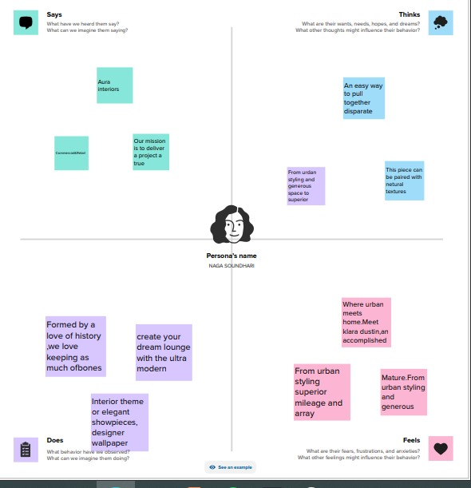
   2. Ideation &Brainstorming map

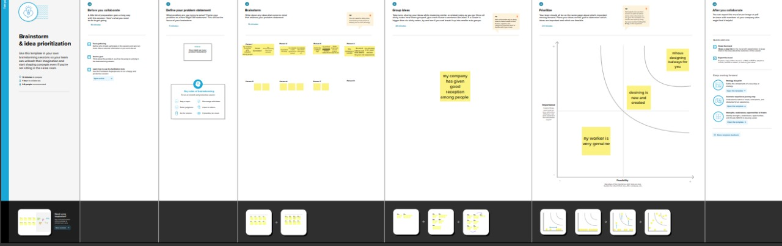

1. **RESULT:**
2. **ADVANTAGES & DIS ADVANTAGES:**
   1. **It will be the token of appreciation .**
   2. **Its dis advantages is it may not be useful all the tine**
3. **APPLICATIONS:**
   1. **It it will be the the token of appreciation.**
4. **CONCLUSION:**

**6.1 We learn a lot of new things about editing and make it useful forothers**